Turnitin學術論文原創性比對報告書 (範例)
Turnitin Originality Report (Example)

比對報告書第一頁 (The first page of the report)
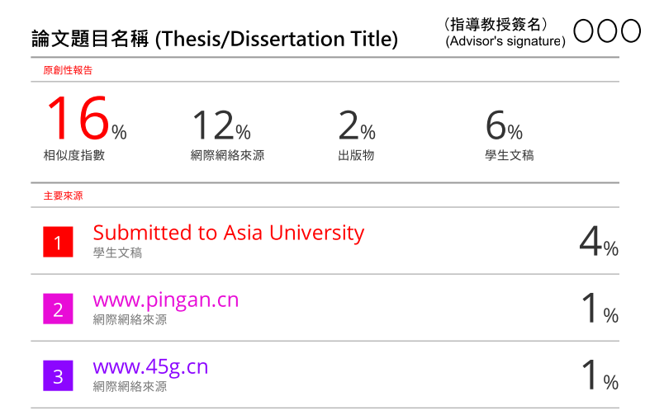

比對報告書最末頁 (The final page of the report)

Exclude sources/matches that are less than …
Exclude bibliography
Exclude quotes
OFF
OFF
OFF

